Future Leaders and Achievers Club
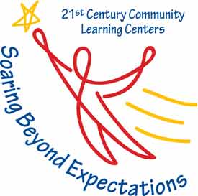
Palmetto Elementary School, Catalina Elementary School, and Lake Como K-8 School offer 21st Century Community Learning Centers after-school programming on their campuses for students in grades 3-5 who are scoring in the lowest 25 percent on state standardized tests. Tutoring by certified teachers helps close academic gaps in English Language Arts, Mathematics and Science. In addition, academic and personal enrichment experiences will support students in achieving performance arts skills, improving decision-making skills and engaging in science, technology, engineering, arts and mathematics (STEAM) project-based learning. Adult family member educational activities support the connection between home and school for participating students.

Palmetto Elementary
2015 Duskin Avenue, Orlando, FL 32839

Site Coordinator:
Candice DaCosta
candice.dacosta@ocps.net
407-858-3150

Hours of Operation:
Monday, Tuesday, Thursday: 3:00pm – 5:45pm
Wednesday: 2:00pm – 5:45pm

Catalina Elementary
2448 29th Street, Orlando, FL 32805

Site Coordinators:
Meagan Dolan
meagan.dolan@ocps.net
407-245-1735

Abby Collins
abby.collins@ocps.net
407-245-1735

Hours of Operation:
Monday, Tuesday, Thursday: 3:30pm – 6:00pm
Wednesday: 2:30pm – 6:00pm

Lake Como K-8 School
2450 E. Gore Street, Orlando, FL 32806
Site Coordinators:
Marquita Outlaw
marquita.outlaw@ocps.net
407-897-6430

Arelia Williams
arelia.williams@ocps.net
407-897-6430

Hours of Operation:
Monday, Tuesday, Thursday: 3:05pm – 5:30pm
Wednesday: 2:15pm – 5:30pm

